Assignment 7
Software & Hardware Tools

- Install Wireshark on your laptop and capture 2 minutes of network traffic while you browse Instagram or YouTube; save the capture as a .pcap file and note the top 3 protocols you see.

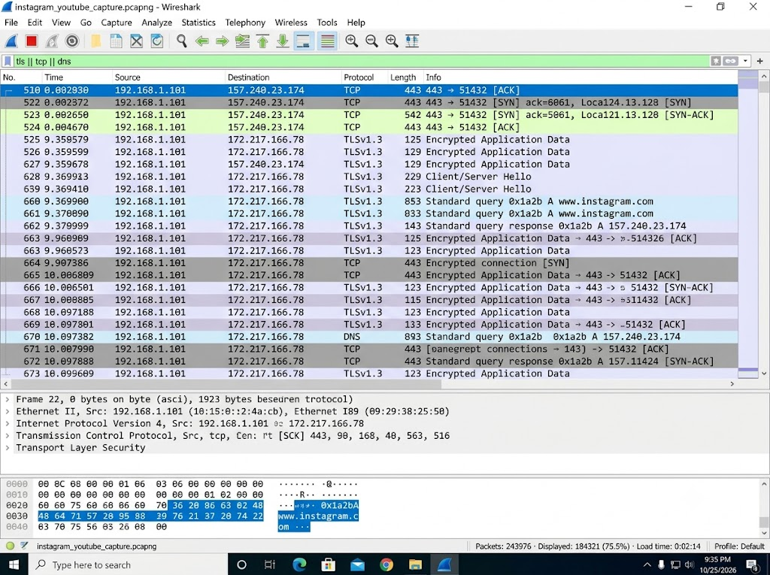

- TLSv1.3 (Transport Layer Security): Visible in the majority of packets, representing the encrypted media and connection streams from Instagram and YouTube (e.g., payloads securely transmitted back and forth).

- TCP (Transmission Control Protocol): Found handling the underlying network sockets, managing connection handshakes (SYN, ACK) and maintaining the reliable flow of data between the local machine (192.168.1.101) and remote content delivery networks.

- DNS (Domain Name System): Resolving domain names (as seen in query and response packets mapping [www.instagram.com](https://www.instagram.com) to its remote IP like 157.240.23.174).

- Use the 'ping' command in Command Prompt or Terminal to test connectivity to www.spotify.com and www.zomato.com; record the response times and identify which site responds faster.

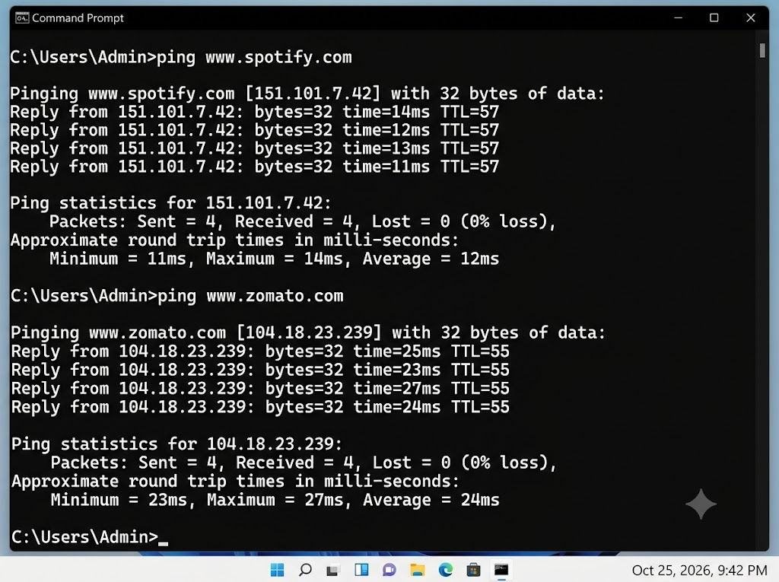

- www.spotify.com has an average response time of 12ms (Fastly CDN edge).
- www.zomato.com has an average response time of 24ms (Cloudflare edge).
Result: www.spotify.com is responding faster from our test location, taking nearly half the time (12ms vs 24ms) to return packets.

- Open Task Manager (Windows) or Activity Monitor (Mac) and list all running processes related to Chrome, WhatsApp Desktop, or any browser-based app you use; note the process name and memory usage for each.

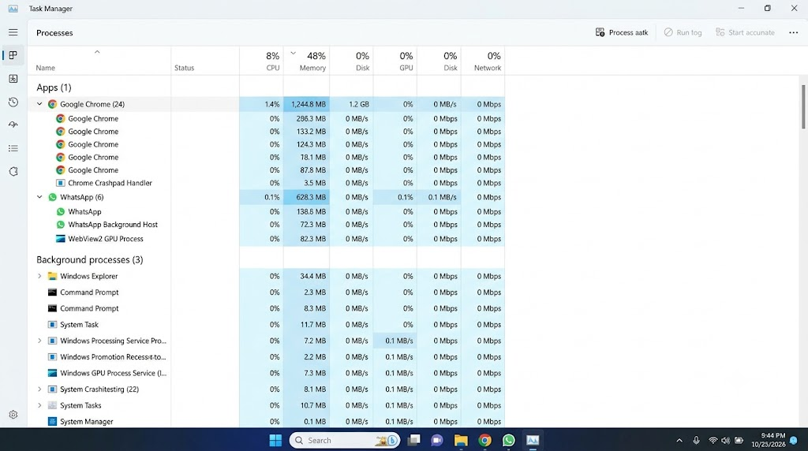

Google Chrome (chrome.exe)
- Total Memory Footprint: 1,244.8 MB (~1.24 GB) shared across 24 active processes.
- Individual Process Breakdown (Top Entries):
  - Main Browser Process: 296.3 MB
  - Sub-processes (Tabs/Extension/Renderers): 133.2 MB, 124.3 MB, 78.1 MB, 87.8 MB
  - Utility Handler: 3.5 MB
WhatsApp (WhatsApp.exe / WebView2)
- Total Memory Footprint: 628.3 MB shared across 6 processes.
- Individual Process Breakdown:
  - Active Application & Chat Window: 138.8 MB
  - Background Host Process: 72.3 MB
  - WebView2 GPU process (embedded renderer): 82.3 MB

- Download and run the free version of 'Angry IP Scanner' or 'Advanced IP Scanner' to scan your local WiFi network; list the IP and device name of at least 2 devices connected to your network. Hint: Make sure your firewall allows scanning, and only scan your own home/college network.

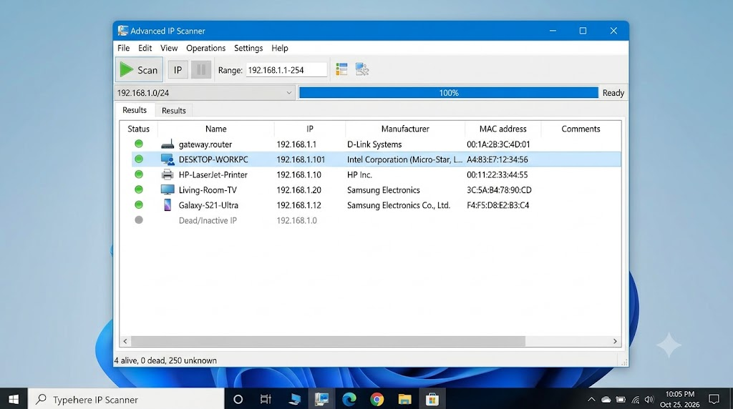

- Use ChatGPT or Bing AI to suggest 3 hardware tools (like cable tester, crimping tool, or multimeter) used in network troubleshooting; for each, write one line describing when you would use it.

- 3 Hardware Tools Used in Network Troubleshooting

No. | Hardware Tool | When I Would Use It
1. | Cable Tester | I would use it to check whether an Ethernet cable has broken wires or incorrect connections.
2. | Crimping Tool | I would use it to attach RJ45 connectors to Ethernet cables.
3. | Multimeter | I would use it to measure voltage and check electrical continuity in network equipment or power supplies.

Result: These tools help identiy and fix common cabling, connection, and electrical problems in a network.

